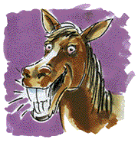

HAY…. HAY…. HAY……
IT’S PARTY TIME!!

You are invited to a horse riding party at Kilronan Equestrian Centre!

TO: _______________________________________________________
FROM: ____________________________________________________

DATE & TIME: _____________________________________________

Please wear comfortable clothing, tracksuits or leggings are perfect.
If you have boots with a small heal, such as welly boots, please wear them too.
All children attending the party will require a fully complete Waiver/Registration Form.

